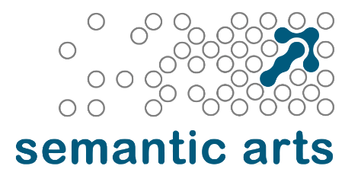
Semantic Arts, Inc.
123 N. College Ave Ste. 218, Fort Collins, CO 80524
www.semanticarts.com

<Insert Date>
<Insert Name>,
We are pleased to make you an offer as a Consultant at Semantic Arts. We understand there may be external factors that affect your start date, as such, please enter your preferred start date at the bottom of this letter.
This offer is contingent on a full background check and your signature of the Employee Agreement document.
Your compensation package includes the following:
- We will start you as an <Enter Position> with a billing rate of <Enter Bill Rate?, until we get your up to speed. We expect to revisit this within your first year.
- Your pay will be based on your billing rate and your averaged chargeability, as described in the attached Breakdown of Consultant Pay.
- You will be paid your incentivized hourly pay rate for all hours worked in a given pay period including overtime, holidays, and PTO.
- An annual bonus plan. In years where the company is profitable (on a cash basis accounting), we award bonuses primarily on non-chargeable time spent on firmwide activities such as recruiting and assisting with sales and marketing.
- Health, dental, and vision insurance benefit program. Details are in the Benefits Book.
- IRA and match up to 3%.
- An individual incentivized training budget of $3,000/year to be used for learning & development purposes.
- A bring your own device policy, where we pay for half your computer hardware.
- A student loan repayment aid program where we will match payments you make to your student loan up to $100/month.
Details are in our handbook, which you will receive upon signing. You can also contact the office manager with questions at office.manager@semanticarts.com
We are all looking forward to having you join the team. There is plenty of work just waiting for you.
Thanks,
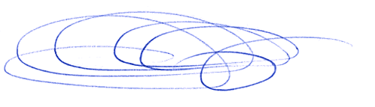  Dave McComb  President  Semantic Arts, Inc. | Accepted:  Name  Date of signature:  Preferred Start Date:

